**VishwaCTF**

**Challenge Name:** Unlocking the Past’s Portal

**Author:** Harshali Patil

**Domain:** Cryptography

**Challenge Description:**

Bellaso, while reading *Alice in Wonderland* on a train, finds herself in a mysterious game with three levels after the train stops in a dark tunnel. Each level has a locked door with a unique key she needs to find to progress and return home.

**Level-1:** **Symbolic Journey**

The train stopped at the “Cistercian Abbey”. A board appeared, instructing her to solve encoded symbols to progress through to the next level.



**Level-2: Door to the past**

She discovers a massive door in the "Retro dial matrix" with a keypad. The password is hidden in the numbers decoded from Level 1.

**Level-3: KEY**

As Bellaso reached the final door, the ancient diary glowed in the dim light, revealing a cryptic message: "In the echoes of your name, the letters weave a tale of hidden ciphers." It instructed her that the only way to escape the Cipherland’s levels was to find the KEY

**Final Step: Cipherland's Key**

Use the decrypted password to obtain a key and escape Cipherland.

**Category:** Cryptography

**Level:** Easy to Intermediate

**Solution:**

**1)**

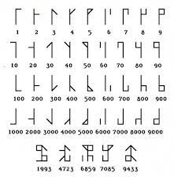

Firstly, when I mentioned “Cistercian Abbey” there was a hint in it that those symbols are of Cistercian Numerals and from that you’ve to get numbers as a password and that password is

77-888-22-88-66-3-99-666-33-777-66-333-77-666-33-66

**2)**

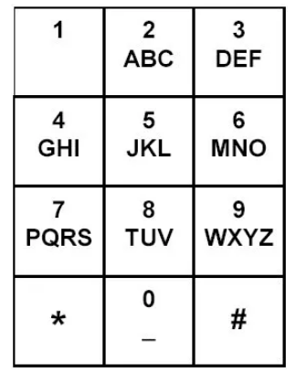

Here ,”Retro Dial Matrix” refers to the old-fashioned basic cell phones and the given encrypted the text contains only repeated decimal numbers. Thus, it seems like the password is encrypted with an old-fashioned keypad just like it was used to type back then. After using previous password that is

77-888-22-88-66-3-99-666-33-777-66-333-77-666-33-66

Q-77

V-888

B-22

U-88

N-66

D-3

X-99

O-666

E-33

R-777

N-66

F-333

Q-77

O-666

B-33

N-66

So the final key is QVBUNDXOERNFQOBN

**3)**

Now in last step, when I mentioned sentence “In the echoes of your name, the letters weave a tale of hidden ciphers.” It says that her name itself is the hint and Bellaso cipher is a method of encrypting alphabetic and when I mentioned the only way to escape the Cipherland’s levels was to find the KEY that means KEY is the keyword for decrypting it

Now to decode QVBUNDXOERNFQOBN we would follow this process:

1. **Align the Keyword**: Write the keyword "KEY" repeatedly under the ciphertext until they match in length:

Ciphertext: Q V B U N D X O E R N F Q O B N   
Keyword: K E Y K E Y K E Y K E Y K E Y K

1. **Decrypt Each Letter**:

Subtract the position of each keyword letter from the corresponding ciphertext letter (A=0, B=1, ..., Z=25).

For example, the first letter 'Q' (16) minus 'K' (10) gives 'G' (6). Repeat this process for each letter.

1. After applying these steps, you get "CIPHERLANDESCAPE."

So the flag is RecruitmentCTF{CIPHERLANDESCAPE}